Directed by Mary Motley & Stuart Walker

Performers

Alison Biggs Rebe Cleveland
Shirley Collins Bryan Creer
Paul Curry Michael Curry
Trevor Curry Will Duke
Sandra Goddard Valmai Goodyear
Derrick Hughes Bob Lewis
Joy Lewis Steve Matcham
Mary Motley Milly Murphy
Rob O'Mahoney Dan Quinn
Janet Reeves Ruth Robotham
Steve Robotham Jill Thompson
Jan Townsend Mike Tristram

The carols and dance tunes are from 18th. and 19th. century handwritten manuscripts mostly held at Barbican House, Lewes, by the Sussex Archaeological Society. In 1982 a selection of the dance tunes was assembled by Dr. Vic Gammon and Anne Loughran and published as 'A Sussex Tune Book' by the English Folk Dance & Song Society.

Dr. Gammon also researched the carols and gathered musicians and singers to perform them under the name 'Hope In The Valley' thirty-five years ago. Mary Motley directed Hope In The Valley when Dr. Gammon moved from Sussex.

The current group was assembled by Stuart Walker in 2013. He has had to stand down for family reasons this year. We are all grateful to him for bringing this beautiful collection of old Sussex music back to life.

SHEPHERDS ARISE!
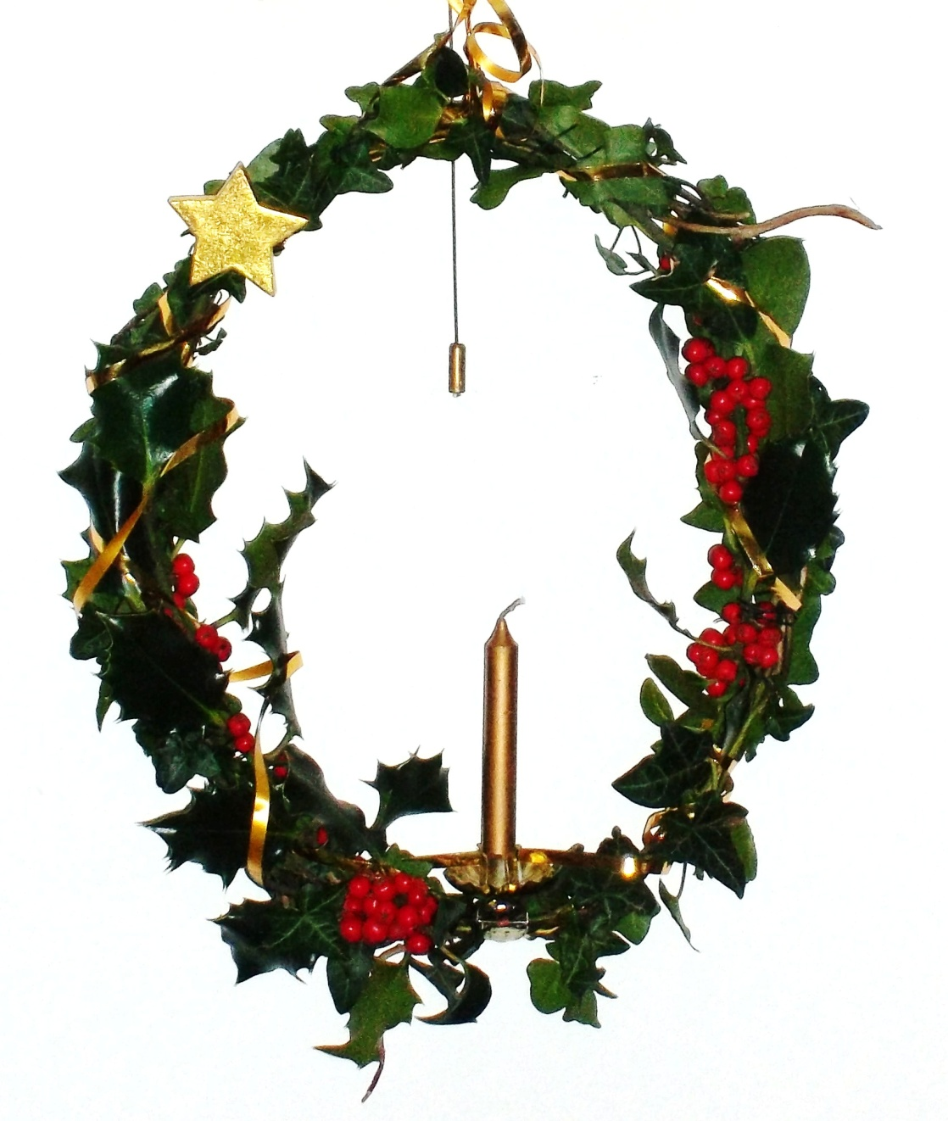Compèred by
SHIRLEY COLLINS

SUSSEX FOLK CAROLS
from SUSSEX CHURCH
Manuscript BOOKS
with flute, fiddle, serpent, bassoon, clarinet, recorder & concertinas.

DANCE TUNES
from SUSSEX Mss SOURCES

SUSSEX MUMMERS PLAY

1 Blow Ye The Trumpet

Reading: 'John Pennicot'

2 Come All You Worthy Christian Men*

Reading: 'The Peasemarsh Choir'

3 On Christmas Night ***

Tunes: Welch's polkas ?

4 Then Let Us Be Merry

Bob Lewis: The Leaves of Life or Will Duke's tunes

Reading: 'The Oxen'

5 Christmas Song (Copper Family) **

Reading: 'The Church Choir'

6 Falmer Carol

Tunes: The Villagers / The Troublesome Cossack ?

Reading: 'The Mummers' Play'

Mummers' play

7 Horsham Tipteerer's Carol *

INTERVAL

Tune: Adjutant Davies's Swiss Guards March

8 Ditchling Carol

Reading: 'Carol singers' (Laurie Lee)

9 While Shepherds Watched Their Flocks By Night

Tunes: Galloway Girth / Untitled Polka

10 Hark, Hark What News

Reading: 'Compton Tipteerers'

11 Compton Tipteerers' Carol *

Reading : 'Mince Pies'

12 In Bethlehem City

Tunes: Cotillion ?

13 The Sinner's Redemption*

Reading: 'A Song for Every Season'

14 Shepherds Arise

* trad arr Vic Gammon
** trad arr Stuart Walker
*** trad arr Vic Gammon/Stuart Walker

